Yahoo PFI Program
The primary means of generating our index is via our free crawl, using our new Yahoo! Slurp crawler. Yahoo! Slurp discovers pages by following links on the web. We update our index with a daily crawl to gather newly created and fast-changing URLs, as well as our main crawl which updates our index incrementally twice per week.
We supplement this free crawl with the paid inclusion program, which allows us to add dynamic database content and other content that we could not otherwise discover and crawl. Currently less than 1% of our index is content that is included via our inclusion programs.
Our paid inclusion programs provide a superior way for sites to interact with us in a clearly structured fashion. These sites get the following
benefits:
1) Control over which URLs they include in the index (subject to content
guidelines)
2) Frequent refresh
3) Clearly defined way to interact with us (for example: clear feed
specifications)
4) Quality review and consultation (for feed customers)
5) Detailed reporting to track and optimize performance
6) Customer service
Participation in Yahoo!'s paid inclusion program does not guarantee rank in the search results. URLs are ranked in search results in the same way as all other URLs from the free crawl. The key drivers of ranking are keyword-specific relevance and site quality, as assessed by our regular search relevance algorithms with input from the quality review process.
(Note that Inktomi Index Connect clients are receiving Yahoo! Search traffic going forward, and Inktomi Search Submit customers are receiving a free trial of Yahoo! traffic until 4/15/04.)
We will also be launching free URL submission during the week of 3/1. This service allows content providers to suggest that the crawler should visit a site during the main crawl cycle. This service is different than paid inclusion in two ways:
1) There is no guarantee that we will crawl and include the URL in the index.
2) As this site potentially could be added to the main crawl, Yahoo! Slurp will follow links from that URL.
This service will reside on the Yahoo.com site and be accessible via a Yahoo! login. This service has been available for the AltaVista and Alltheweb Indices previously and the tradition will continue with Yahoo! Search

What are the benefits of link building?

Here are some of the main benefits:

A. Third Party Referals. Following a link is one of the most popular ways for people to find new sites. If a site or a writer that you respect gives a link to further resources, then because of that respect you’re likely to follow it. Therefore, the more inbound links you have to your site, the greater the opportunities for people to find your valuable content.

B. Search engines give sites with good inbound links a higher ranking. The logic goes that if other sites link to you then you must have content of value.

C. Having a linking strategy forces you to ask the fundamental question, "Why would anyone want to link to you?" The answer of course is that you provide something of value (CONTENT): you need to be clear about what that value is.

D. Inbound links help to build trust. If people see that a popular or respected site links to you, then their level of trust in what you say and what you offer is likely to be higher.

E. Perhaps most importantly, you become part of a community. In every field of activity on the web there will be a number of key sources. Linking to them and providing valuable content that they can link to will make you a part of a powerful virtual network.

F. Clicks, page impressions, and time spent, from a organic search > site xxx.com > yoursite.com count for site xxx.com and yoursite.com

G. Spiders will crawl more of your pages.

H. Increase Page Rank On Internal Pages.

Bottom Line, Create good content, link to great content and great content will link to you.

Link Popularity

The basic concept of link popularity is simple. If someone links to your site, you get a vote. If you link to another site they get a vote. *explain votes vs links on page*

Developing an effective linking strategy is not about getting as many links as possible: it is about putting your resources into getting quality links that will drive traffic to your site and get the attention of search engines.

Do not try to spam search engines: History has seen the rise and fall of keyword spamming, free-for-alls, link farms, hidden links and others. The effort involved is huge and the success if any is small. DONT DO IT!

By implementing a linking strategy you attract more visitors, provide additional content and resources for them, you learn more about your industry online and your competitive position within it, you build trust and you become part of an online community. These benefits can bring much greater reward that search engine ranking.

Linking strategy demands an ongoing commitment.

Human interaction process that is at the heart of an effective linking strategy. use software to track links not aquire links.

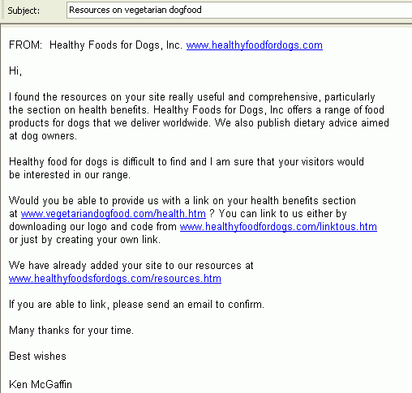

Who links to you now?
You can find out easily using either Google or AltaVista or one of the online link popularity checkers.
In Google, enter:

Understand why external sites would want to link to you
The simple answer is because you are able to provide something of value to their visitors that also enhances their own site. Without that value, no worthwhile external site will link to you.\
Check Alexa ranking
Checking For Webmaster Tricks To Hide Outbound Links
- scripts
- image maps
- characters in url
- links page not cached
- page rank of site

