Is this website banned?
http://www.golf-and-golfer.com

How to Tell if Your Website is Banned.
http://www.pandia.com/features/banned.html
How To Become A GSA Schedule Contractor
http://www.gsa.gov/Portal/gsa/ep/channelView.do?pageTypeId=8199&channelPage=%2Fep%2Fchannel%2FgsaOverview.jsp&channelId=-13464
When You Become A GSA Contractor
https://www.gsaadvantage.gov/advgsa/advantage/information/page.do?BV_UseBVCookie=Yes&keyName=VEND_HELP
University Of Houston offers free GSA counseling http://www.sbdc.uh.edu/sbdc/PTAC.asp
-----------------------------------------------------------------------------------------------------------
Yahoo Launches “Search Assist”
- Allow for multiple key phrase searches from same window without reloading page.
- Fulfills Yahoo’s promise of one click searching.
- Search Assist make yahoo’s search very helpful.
- Using Ajax which speeds up search.
- Being able to turn off Search Assist practically eliminates its potential to be annoying
- Improves the “stickiness” of Yahoo’s web site. If you’re finding what you want and you don’t have to leave a site to get to what you’re looking for, you’d be inclined to stay a little longer. Which is good for us because Yahoo will become stronger and our eggs will be spread over more baskets?
Your Web site might focus on holiday recipes. Food is a topic that is near and dear to the hearts of a lot of people, so one can imagine that this is a pretty competitive keyword. Look what you get when you put that keyword into Yahoo Search Assist, however: http://search.yahoo.com/search?p=holiday+recipes&fr=yfp-t-501&toggle=1&cop=mss&ei=UTF-8
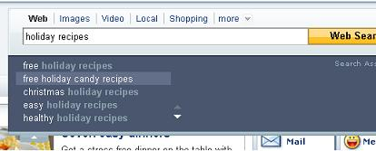
You can be more specific about the focus of your site, attracting a subset of web surfers interested in specific categories of holiday recipes. Do you want to lure those looking for healthy holiday recipes? Or perhaps the busy folks who need easy holiday recipes fit your target demographic better? You can scroll for more options. And all this without even clicking to do the web search!
So what happens when you click the web search? You get all the sites that Yahoo thinks show content relevant to the key phrase. But if you hit the little tab underneath the search window, you also get to explore related concepts, as you can see in the screen shot below:
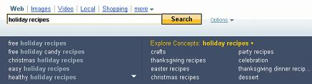
In addition to recipes for various specific holidays, related concepts include party recipes, crafts and dessert. You can also scroll sideways for more ideas.
Long Tail Of Search
Every single one of these related concepts, as well as the original options Yahoo turned up for you with Search Assist, is a possible keyword related to your main keyword choice, “holiday recipes.” Many of them help you with the “long tail” of search. These are longer, more specific search terms that will also increase close rates. Web surfers make fewer searches using them, but there are also fewer web sites trying to compete for those words. Searchers who use long tail keywords know what they’re looking for, and are more likely to convert than searchers who use more general keywords.
Those of you who are selling goods and/or services that are affected by holiday trends. I’m talking to sellers of Halloween costumes, Thanksgiving turkeys, Christmas hams, gifts and holiday decorations. Those who sell goods and/or services that are affected by the seasons: landscape lighting companies, Landscapers, construction companies, wedding consultants, Google trends can help.
Google Trends
http://www.google.com/trends?q=christmas+trees
You want data for at least the last 12 months, and if your business is local you want to specify your particular region of the world. Let’s try a search for Christmas trees, for the last 12 months, in all regions of the world. Check out the screen shot below:
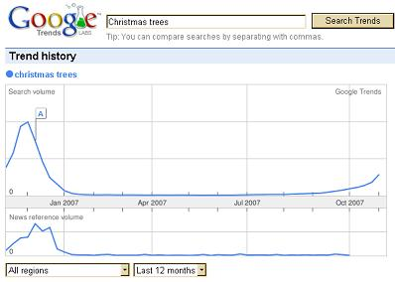
As you can see, web surfers started thinking about Christmas trees in September this year. If you didn’t start your SEO for this phrase some time in August, you missed the boat..
But what if you’re trying to optimize for Valentine’s Day? The news is quite a bit better:
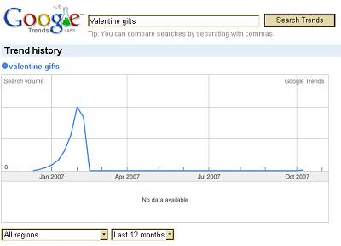
It looks like Valentine’s Day hits the radar of most searchers by the middle of December. Remember, you want to start optimizing your site some time before searchers start getting serious, so your campaign will have picked up a little steam and be registering in the search engines right around the time searchers are ready to think about what you have to offer them.
Use Google To Find Synonyms?
Just use the tilde ( ~ ) in front of the word if you’re interested in finding out its synonyms. What Google returns is not a list of synonyms, exactly, but a list of sites whose content is related to that word and its synonyms. If you’re having problems coming up with keywords, you can try using this to help you brainstorm for ideas.
For example, a searcher interested in food facts, nutrition, and cooking information might put ~food~facts into Google’s search box. The first link returned is for www.foodfact.info, followed by several “food facts” sites, with a couple of cooking tips and recipe sites near the bottom of the first page. The first entry on the second page is from Restaurant.org, and it features “Economic and statistical information about the US restaurant industry.”
Think Outside The Box
Each of the links includes snippets from the sites, of course, and it’s interesting to see what Google put in bold in each one. Food, of course, and facts; but in the snippet from Restaurant.org, both “information” and “restaurant” are bolded, to show that they are related to “facts” and “food” respectively. Google offers many different little tricks you can do to help you with your site’s SEO. In fact, all of the major search engines offer advanced search features that can be helpful when used for SEO. All you have to do is think outside the box.
-----------------------------------------------------------------------------------------------------------
Five Effective Social Networking Strategies
- Joint Ventures (Short - Long Term Marketing Strategy)
Joint ventures are the fastest way to get traffic and sales for your site.
Basically, you contact ezine publishers who own complimentary sites, offer them a copy of your product, as well as other incentives like higher commissions, and ask them to offer your product to their readers.
Although it can take a little while to find complementary sites, you can increase the number of partners marketing your product, and you can get immediate traffic.
Joint Venture Network
You can use forums to help you find joint venture partners. However, there is an easier way to find joint venture partners. JV-Network. It's free to join, but you need an invitation: JV-Network – http://JV-Network.com/

2. PR (Short - Long Term Marketing Strategy)
Press releases, or news releases, can help you effectively get traffic to your business because, unlike advertising, you are offering readers news about your business.
What Is Usenet

Usenet Readers. I like “Free Agent” & Google Groups
The key here is that it's news. You can make this technique even more effective when you build a list of local contacts to submit your releases to. Online news releases help you build your business globally; local releases will help you build your business in your community, and you have a better chance of getting read.
http://www.prweb.com
http://www.press-world.com/
http://www.free-press-release.com/
http://www.press-base.com/
* Also Publish All Articles Thru http://www.isnare.com/
3. Free Ebooks and Reports (Long Term Marketing Strategy. Also Use As Incentives, to sign up for newsletters or free download for membership signups etc…).
Like articles and press releases, this is a viral marketing strategy. You can create brandable copies of your report or ebook so that others can add their information about their businesses and then give your ebook away. This method can be even more effective if you have an affiliate program.
http://www.ebookdirectory.com
http://www.ebookpalace.com
http://ebookjungle.com

4. Directories (Long Term Marketing Strategy)
Most people don't think about using directories as a way to build their businesses, but this can be a very effective way to do it.
The actual strategy here is linking. There are many directories where you can post your site for free, and they don't require that you link back to them. This increases the number of links that you have pointing back to your site, increasing your Google page rank, as well as increasing your traffic.
The most important thing you can do here is to vary the anchor text that you use in your links. Google is currently penalizing sites that use the same anchor text in their links.
http://www.seo-lab.com/directory-articles/best-free-directories.php

5. Networking (Short - Long Term Marketing Strategy)
Networking is similar to marketing on forums, but you will find networking to be more targeted than forums.
You will also have more tools available to help you promote, like blogs, press release posts, and article posting. These sites will also often allow you to use classified advertising to promote your products and services.
Ongoing Trend in Business Networking
http://www.ecademy.com
http://www.ryze.com
http://www.linkedin.com
Ecademy is a Blogging tool that should be included in the armory of the
SEO Marketing Director/Manager of every business.

- Ecademy gives you a head start because you are blogging on a website that has an Alexa ranking of 1,500. i.e. it is the 1,500th most visited website in the world.
- Ecademy is like writing an article that appears in the Local, National & International Press and National Press as opposed to appearing in the local paper.
- Ecademy charges a small sum of money per month where you can create a profile, which will appear on Google and then various Blogs and Marketplace listings over time
- Another key to success will be using the keywords and phrases that relate to your business.
- Users can pull your RSS feeds.
With a focussed Ecademy Profile, blogs and articles that relate to your key products and services you will begin to get higher rankings for search terms that relate to your company.
-----------------------------------------------------------------------------------------------------------

